**IOT Based Smart Agriculture Monitoring System**

**Abstract**:- Agriculture is the primary occupation in our country for ages. But now due to migration of people from rural to urban there is hindrance in agriculture. So to overcome this problem we go for smart agriculture techniques using IoT. This project includes various features like GPS based remote controlled monitoring, moisture & temperature sensing, intruders scaring, security, leaf wetness and proper irrigation facilities. It makes use of wireless sensor networks for noting the soil properties and environmental factors continuously. Various sensor nodes are deployed at different locations in the farm. Controlling these parameters are through any remote device or internet services and the operations are performed by interfacing sensors, Wi-Fi, camera with microcontroller. This concept is created as a product and given to the farmer’s welfare.

1.INTRODUCTION TO SMART AGRICULTURE As the world is trending into new technologies and implementations it is a necessary goal to trend up in agriculture also. Many researches are done in the field of agriculture. Most projects signify the use of wireless sensor network collect data from different sensors deployed at various nodes and send it through the wireless protocol. The collected data provide the information about the various environmental factors. Monitoring the environmental factors is not the complete solution to increase the yield of crops. There are number of other factors that decrease the productivity to a greater extent. Hence automation must be implemented in agriculture to overcome these problems. So, in order to provide solution to all such problems, it is necessary to develop an integrated system which will take care of all factors affecting the productivity in every stage. But complete automation in agriculture is not achieved due to various issues. Though it is implemented in the research level it is not given to the farmers as a product to get benefitted from the resources. Hence this paper deals about developing smart agriculture using IoT and given to the farmers.

2. LITERATURE SURVEY The existing method and one of the oldest ways in agriculture is the manual method of checking the parameters. In this method the farmers they themselves verify all the parameters and calculate the readings.

[1]It focuses on developing devices and tools to manage, display and alert the users using the advantages of a wireless sensor network system.

[2]It aims at making agriculture smart using automation and IoT technologies. The highlighting features are smart GPS based remote controlled robot to perform tasks like weeding, spraying, moisture sensing, human detection and keeping vigilance.

[3]The cloud computing devices that can create a whole computing system from sensors to tools that observe data from agricultural field images and from human actors on the ground and accurately feed the data into the repositories along with the location as GPS coordinates.

[4]This idea proposes a novel methodology for smart farming by linking a smart sensing system and smart irrigator system through wireless communication technology.

[5]It proposes a low cost and efficient wireless sensor network technique to acquire the soil moisture and temperature from various location of farm and as per the need of crop controller to take the decision whether the irrigation is enabled or not.

[6]It proposes an idea about how automated irrigation system was developed to optimize water use for agricultural International Journal on Recent and Innovation Trends in Computing and Communication crops. In addition, a gateway unit handles sensor information.

[7]The atmospheric conditions are monitored and controlled online by using Ethernet IEEE 802.3.The partial root zone drying process can be implemented to a maximum extent.

[8]It is designed for IoT based monitoring system to analyze crop environment and the method to improve the efficiency of decision making by analyzing harvest statistics.

[9]In this paper image processing is used as a tool to monitor the diseases on fruits during farming, right from plantation to harvesting. The variations are seen in color, texture and morphology.

[10]In this paper, greenhouse is a building in which plants are grown in closed environment. It is used to maintain the optimal conditions of the environment, greenhouse management and data acquisition.

3. PROPOSED WORK In the field section, various sensors are deployed in the field like temperature sensor, moisture sensor and PIR sensor. The data collected from these sensors are connected to the microcontroller through RS232.

In control section, the received data is verified with the threshold values. If the data exceeds the threshold value the buzzer is switched ON and the LED starts to blink. This alarm is sent as a message to the farmer and automatically the power is switched OFF after sensing. The values are generated in the web page and the farmer gets the detailed description of the values.

In manual mode, the user has to switch ON and OFF the microcontroller by pressing the button in the Android Application developed. This is done with the help of GSM Module.

In automatic mode, the microcontroller gets switched ON and OFF automatically if the value exceeds the threshold point. Soon after the microcontroller is started, automatically an alert must be sent to the user. This is achieved by sending a message to the user through the GSM module.

Other parameters like the temperature, humidity, moisture and the PIR sensors shows the threshold value and the water level sensor is used just to indicate the level of water inside a tank or the water resource.

4. HARDWARE USED PIC16F877A-MICROCONTROLLER: The PIC microcontroller 16F877A is one of the most popular microcontrollers in the industry. It is user convenient and easier to handle. The coding or programming of this controller is also easy. The program that is coded can be easily erased due to the flash memory technology. The microcontroller has wide range of applications used in many huge industries. It is used in security, remote sensors, home appliances and industrial automations. An EEPROM is also featured which is used to store the information permanently like transmitter codes and receives frequencies and some other related data.

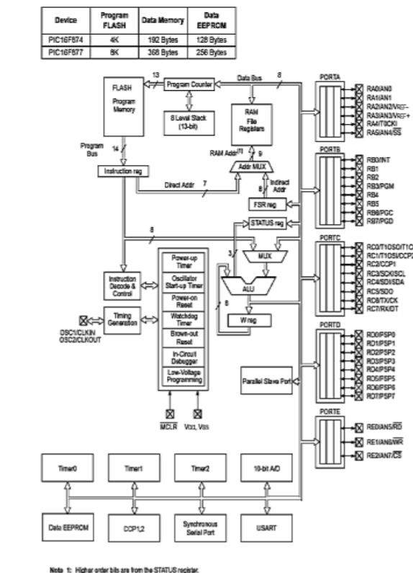

GSM MODULE

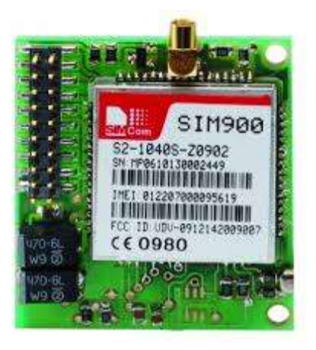

GSM Modem can accept any GSM network operator SIM and it can act just like a mobile phone with its own unique phone number. The necessity to use this is it can use RS-232 protocol which can be easily connected to the controller. It can be used like a phone where it can send and receive SMS and make a call. The GSM modem is connected to the controller through RS232. The SMS is sent through the terminal to the number using AT Commands. “AT-Attention” commands which is used by the controller to control the GSM to perform the desired function. It also has reverse voltage protection and the LED notifications. It is operated in 900/1800 MHz.

SOIL MOISTURE SENSOR

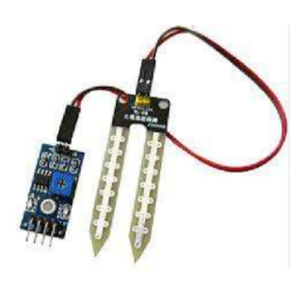

Soil moisture sensor is sensor has long life which will afford the farmer at a minimum cost. Soil moisture sensor is a sensor which senses the moisture content of the soil. The sensor has both the analog and the digital output. The digital output is fixed and the analog output threshold can be varied. It works on the principle of open and short circuit. The output is high or low indicated by the LED. When the soil is dry, the current will not pass through it and so it will act as open circuit. Hence the output is said to be maximum. When the soil is wet, the current will pass from one terminal to the other and the circuit is said to be short and the output will be zero. The sensor is platinum coated to make the efficiency high. The range of sensing is also high. It is anti-rust and so the sensor has long life which will afford the farmer at a minimum cost.

TEMPERATURE SENSOR

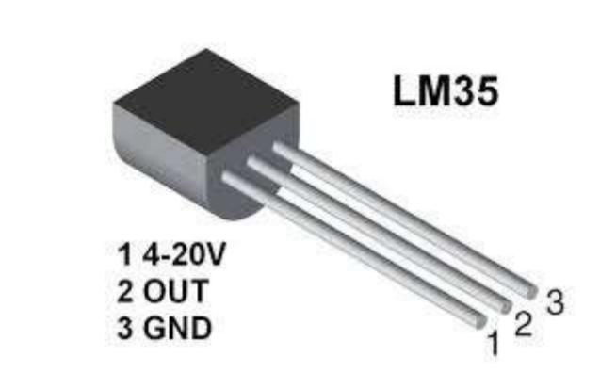

The LM 35 sensor is highly used because its output voltage is linear with the Celsius scaling of temperature. It does not provide any external trimming. It has a wide operating range. The maximum output is 5V. The output will increase 10mV for every one degree rise in temperature. The range is from -55 degrees to +150 degrees. There are three terminals as Vcc, Ground and the analog sensor. It consumes minimum amount of electricity. Thus, it is energy efficient. It is very efficient in horticulture. It is user friendly to use.

PIR SENSOR

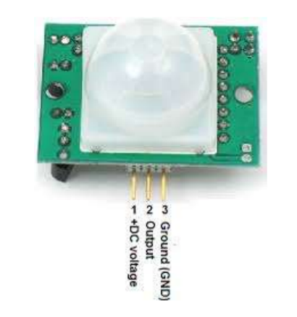

All objects with a temperature above absolute zero emit heat energy in the form of radiation. It is invisible to the human eye since it radiates infrared wavelengths. PIR sensors don’t detect or measure heat, instead they detect the infrared radiation emitted or reflected from an object. It is used to detect the movement of people, animals or other objects. They are commonly used in burglar alarms and automatically activated lighting systems. When a human passes in the field, the temperature at that point will rise from room temperature. The sensor converts the resulting change into a change in the output voltage and this triggers the detection.

5. SOFTWARE USED PROTEUS 8 SIMULATOR

Proteus 8 is one of the best simulation software for various circuit designs of microcontroller. It has almost all microcontrollers and electronic components readily available in it and hence it is widely used simulator. It can be used to test programs and embedded designs for electronics before actual hardware testing. The simulation of programming of microcontroller can also be done in Proteus. Simulation avoids the risk of damaging hardware due to wrong design.

6. EXPERIMENTATION & RESULTS

The hardware is interfaced with all the sensors in the board. The hardware components include the microcontroller, buzzer, relay, ADC converter, GSM module and all the sensors interfaced. The board is inserted with a SIM card which is used to communicate with the owner and the recorded values. The output shown below denotes the temperature, soil moisture condition and the intruder detection. The second result is the output from the Android Application that is developed in the mobile phone. It determines the temperature, humidity, moisture and the intruder detection. 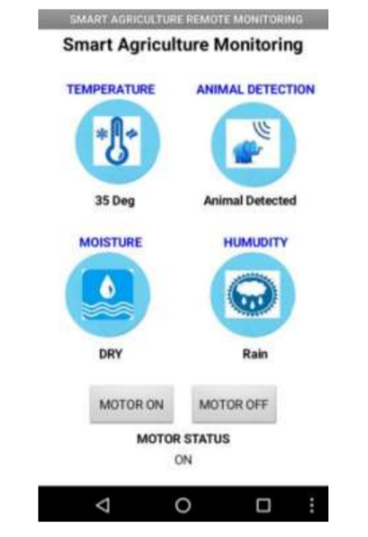 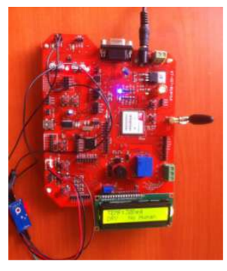

7. FUTURE WORK & CONCLUSION

For future developments it can be enhanced by developing this system for large acres of land. Also the system can be integrated to check the quality of the soil and the growth of crop in each soil. The sensors and microcontroller are successfully interfaced and wireless communication is achieved between various nodes. All observations and experimental tests prove that this project is a complete solution to field activities and irrigation problems. Implementation of such a system in the field can definitely help to improve the yield of the crops and overall production.

**GAPS IDENTIFIED:**

Though the idea of detecting the moisture level and the temperature of the soil is fine , yet this don’t make a perfect smart agriculture system. From this idea the farmer don’t get the information on how much yield is produced , what are the deficient minerals in the soil, what precautions and measures are to be taken to overcome these defects .

For instance the pH level varies from crop to crop and the nutrients in the soil gets dissolved overtime and needed to be added precisely , and after knowing that they need to add the fertilizer of required quantity.

REFERENCES

[1] K.Lakshmisudha, Swathi Hegde, Neha Kale, Shruti Iyer, “ Smart Precision Based Agriculture Using Sensors”, International Journal of Computer Applications (0975- 8887), Volume 146-No.11, July 2011

[2] Nikesh Gondchawar, Dr. R.S.Kawitkar, “IoT Based Smart Agriculture”, International Journal of Advanced Research in Computer and Communication Engineering (IJARCCE), Vol.5, Issue 6, June 2016.

[3] M.K.Gayatri, J.Jayasakthi, Dr.G.S.Anandhamala, “Providing Smart Agriculture Solutions to Farmers for Better Yielding Using IoT”, IEEE International Conference on Technological Innovations in ICT for Agriculture and Rural Development (TIAR 2015).

[4] Chetan Dwarkani M, Ganesh Ram R, Jagannathan S, R. Priyatharshini, “Smart Farming System Using Sensors for Agricultural Task Automation”, IEEE International Conference on Technological Innovations in ICT for Agriculture and Rural Development (TIAR 2015).